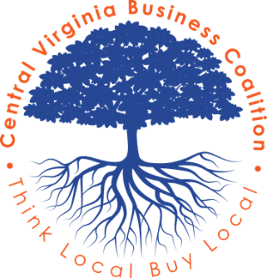
Central Virginia Business Coalition
147 Mill Ridge Road, Suite 209
Lynchburg, Virginia, 24502

July 12, 2019

To Whom It May Concern:

The Central Virginia Business Coalition is dedicated to promoting and helping grow businesses in the Central Virginia area and push the Think Local, Support Local mentality throughout our community. We support the businesses in our area by growing their visibility, offering seminars and business presentations, providing free and low cost marketing benefits and connecting them with the community through the events we host.
We are excited to be hosting the 60th Annual Lynchburg Christmas Parade! This year’s theme “Snowflakes & Diamonds: Sparkling through Time” will be held on Sunday December 8, 2019 and will step off from Lynchburg City Stadium at 4pm. We are anticipating a large community involvement this year as we continue to see crowd grown year after year. Through our connections with local television stations, magazines, newspapers and our ownership in our own digital billboards, these events will be highly publicized.
We would be honored if your business would consider becoming a sponsor of this highly anticipated community event! Please take a look at the 3 Christmas Parade Event Sponsor Options listed below and return the bottom portion with your choice marked. Sponsorships can be paid in Full or Monthly installments leading up to the December event. (Please note that with a monthly, the amount would be divided by number of months left in 2019.)

DIAMOND LEVEL SPONSORSHIP - $800.00
- Recognition as a Diamond Level Sponsor on all Media/Promotions (TV, Radio, Print, etc.)
- Annual CVABC Membership Included
- Parade Entry Waived
- Logo with link on Christmas Parade Website
- Large Color logo on banner recognizing sponsors appearing at or near the start of the Lynchburg Parade
- Logo on Signage at Media/Judge’s Tent
- Sponsor Designation given by DJ at Judges Station leading up to and during Parade.
- Social Media recognition leading up to event.
SILVER LEVEL SPONSORSHIP - $500
- Recognition as a Silver Level Sponsor on all Christmas Parade flyers & Christmas Parade Billboard
- Annual CVABC Membership Included
- Parade Entry Waived
- Logo with link on Christmas Parade Website
- Medium Color logo on banner recognizing sponsors appearing at or near the start of the Lynchburg Parade
- Social Media recognition leading up to the event
BRONZE LEVEL SPONSORSHIP - $250
- Annual CVABC Membership Included
- 25% off Christmas Parade Entry
- Name listed as Bronze sponsor on flyers & Christmas Parade website.
- Business Name Listed on banner recognizing all sponsors appearing at or near the start of the Lynchburg Parade.
- Social Media recognition leading up to the Christmas Parade

Thank you for your consideration of supporting the 60th Annual Lynchburg Christmas Parade within our community! Please mail this form back to Heather Alto, Executive Director, 147 Mill Ridge Rd, Suite 209, Lynchburg Va 24502. If you’d like an online invoice for your sponsorship, you can email the form to Heather@cvabc.org.

Yes, please put my organization down as a 60th Anniversary Christmas Parade Sponsor at the Level Listed Below!
Diamond Level SILVER Level BRONZE Level

Company Name: ____________________________
Contact: ______________________________
Mailing Address: _____________________________________________________________________
Phone: ___________________________
Email: ____________________________________________
Please bill me: In Full Monthly
Signature: __________________________________ Date: __________________________

